OUBOV_TC_01_Buy Put Option Double Knout Out FXO

This test case validates that a Buy Put Option Double Knout Out FXO transaction created  
in UOB WUI was reflected in UOB OneView after successful transaction

Order Checked

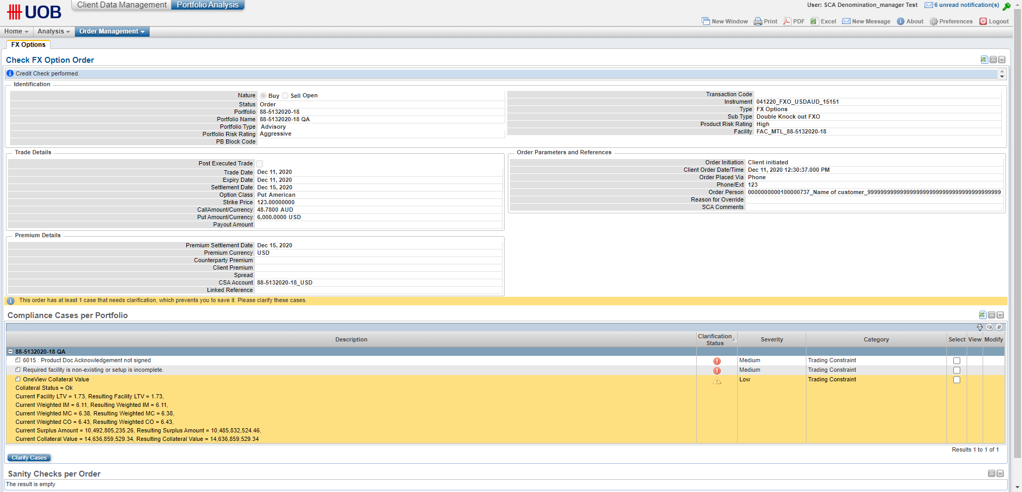

Compliance Cases – 3

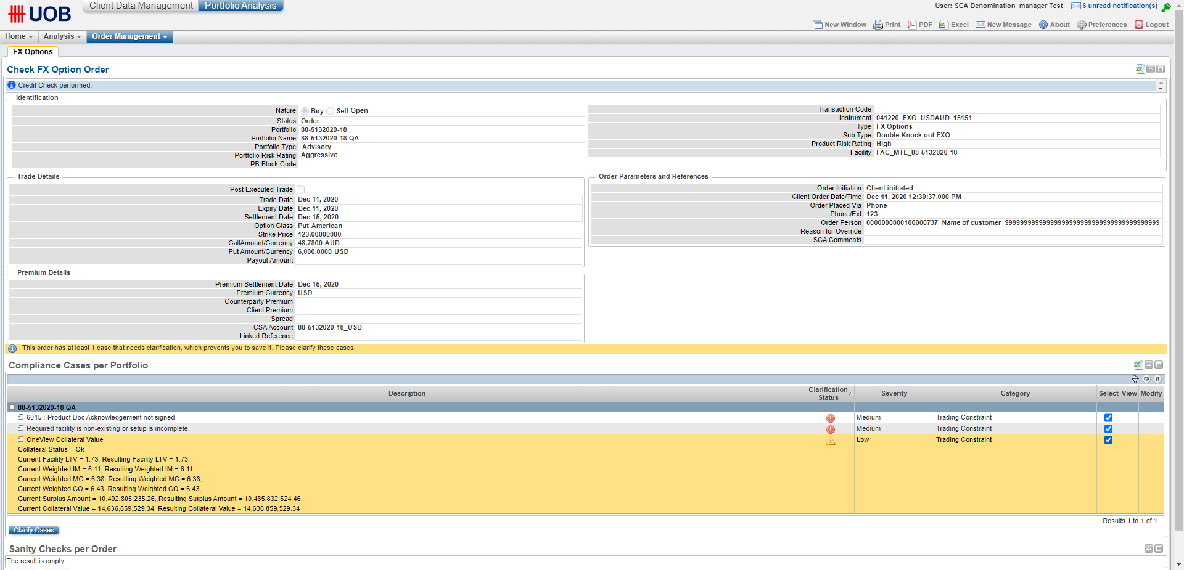

Compliance Cases Resolved

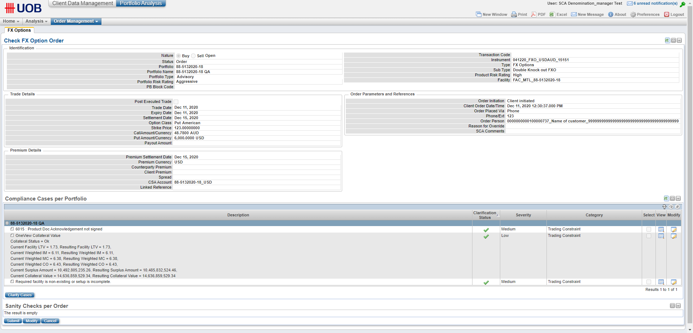

Order Transaction Code A88-5132020-10000698

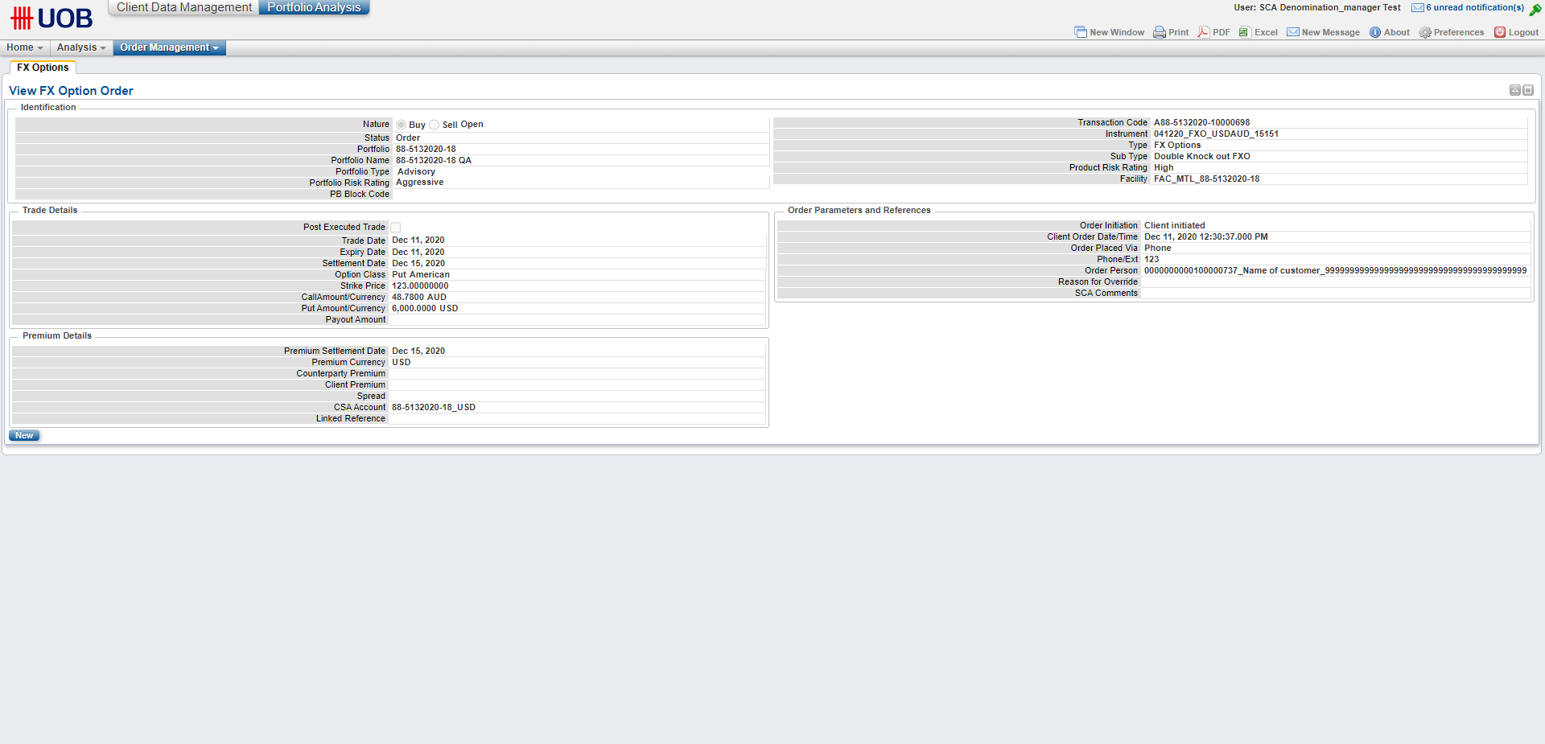

Signed in as Credit User 1

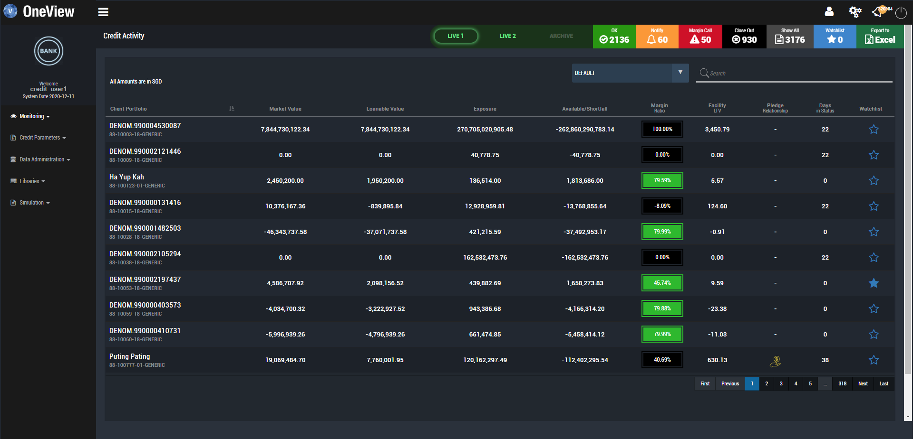

Liabilities screen

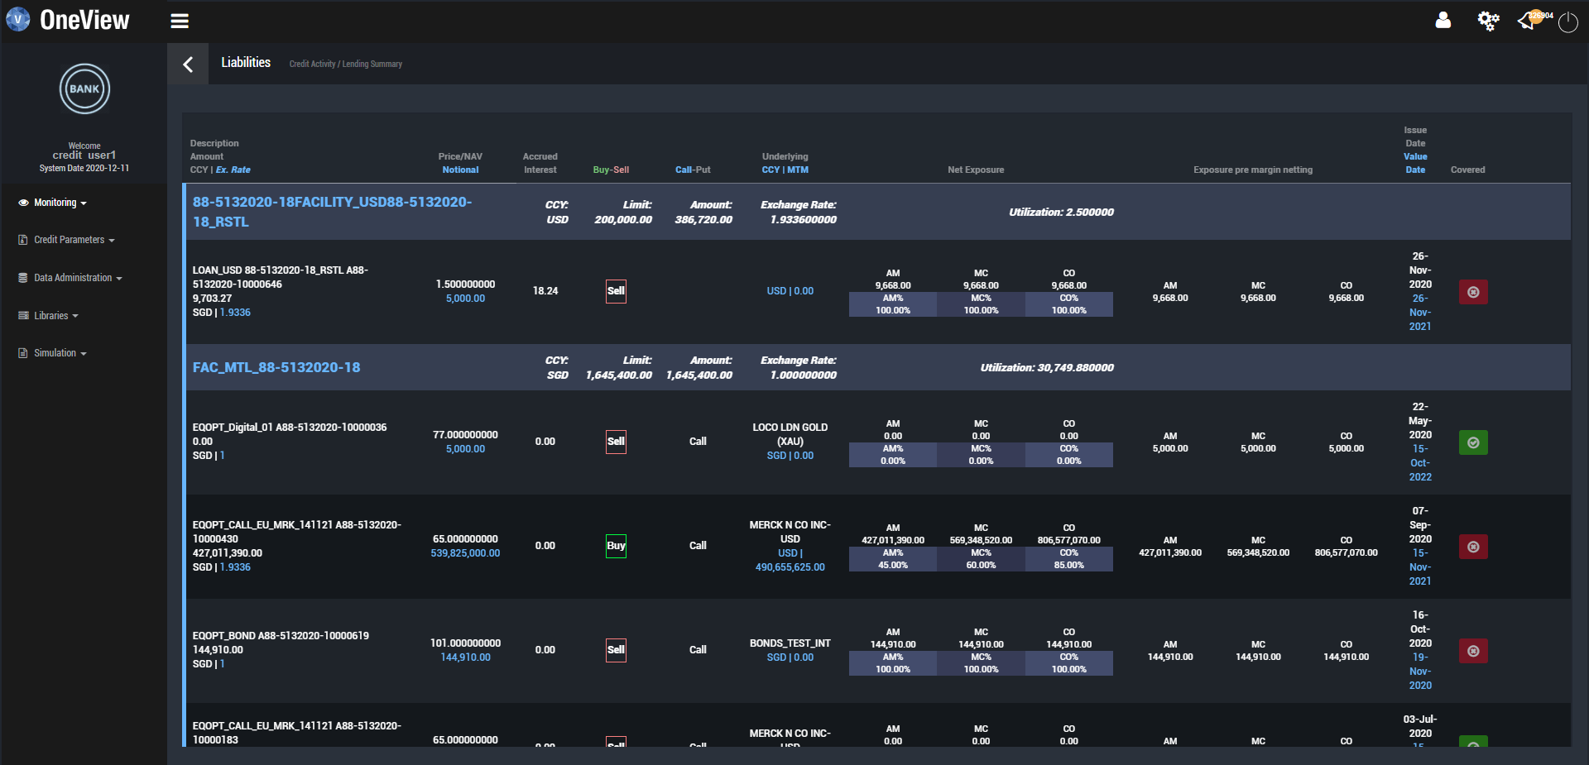

Instrument 041220_FXO_USDAUD_15151 is displayed

